MD2201: Data Science

Name of the student: Rajeev Tapadia Roll No.: 67

Div:C Batch:3

Date of performance:

Experiment No.4

Title: Regression .
Aim: i. To construct a simple linear regression model
ii. To construct a multiple linear regression model.

Software used: Programming language R.

Data Set: Toy Sales Dataset

Code Statement:
- Simple Linear Regression
- Consider the Toy sales data set.
- Apply simple linear model considering response as Unit sales and explanatory variable as Price.
- Plot the scatter plot and draw the regression.
- What are values of R-square and residual standard error? (Write in conclusion)
- Display all predicted values from the designed model and the corresponding values of error.
- model <- lm(formula = sales ~ price, data = dataset)
- abline(model, col = "red")
- summary(model)$r.squared
- summary(model)$sigma
- predicted <- predict(model, newdata = dataset)
- sales - predicted

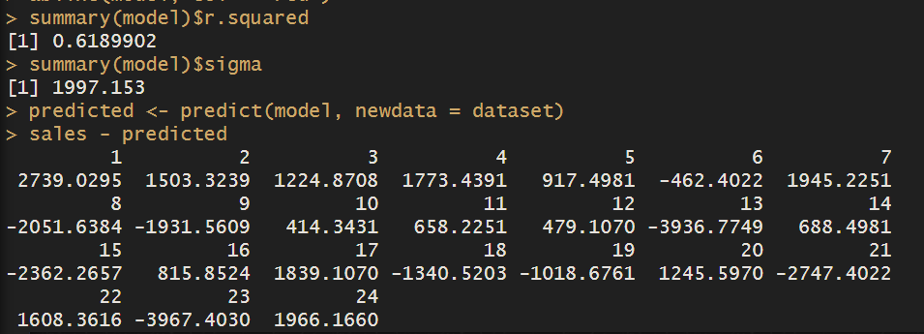

- Multiple Linear regression:
- Consider Toy sales data set.
- Consider all variables to fit the regression model.
- Compare the R-square of SLR with MLR. (Write in conclusion)
- Which of the variable is more significant? Why? (Write in conclusion)
- Can you reject Null hypothesis for promotion expenditure variable? (Write in conclusion)
- Which scenario from the following you will select to be applied to get maximum number of Unit sales? (Write in conclusion)
- Price=9.1$, Adexp=52,000$, Promexp=61,000$
- Price=8.1$, Adexp=50,000$,Promexp=60,000$
- full_model <- lm(Unitsales ~ Price + Adexp + Promexp, data = dataset)
- summary(full_model)

- coef_summary = summary(full_model)$coefficients
- names(coef_summary[which(coef_summary[,4] < 0.05), 1])

- coef_summary[grep("Promexp", names(coef_summary)), 4]

- predict(full_model, newdata = data.frame(Price = 9.1, Adexp = 52, Promexp = 61))
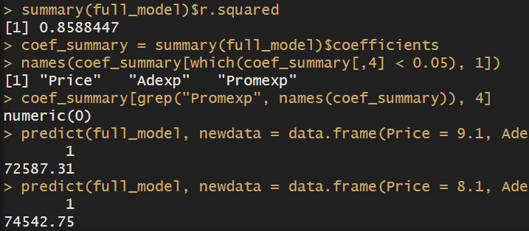
- predict(full_model, newdata = data.frame(Price = 8.1, Adexp = 50, Promexp = 60))

Conclusion:

A linear regression analysis was performed on the Toy Sales data. Simple linear regression with Price as the explanatory variable showed a relationship with Unit Sales. However, including all variables in a multiple linear regression model explained a larger portion of the variance in Unit Sales (compared to R-squared of simple regression). It was found the R squared value of MLR > SLR. Finally, by analyzing the coefficients of the full model, we can predict which scenario (given options) is likely to lead to maximum unit sales.

